 Habib University
EE-437 Renewable energy systems – Fall 2025

Time = 40 minutes | Quiz 02 | Max Points: 20

CLO 1 - 8 marks
Question 1 [2 points]: Explain solar altitude and azimuth.
Altitude: The angle between the sun’s ray and horizon.
Azimuth: The compass direction of the Sun along the horizon, measured clockwise from North (0°) through East (90°), South (180°), and West (270°).
Question 2 [2 points]: Differentiate between flat plate collectors and evacuated tube collector.
Flat Plate Collectors: Simple design with a flat absorber plate; less efficient, especially in cold or cloudy conditions.
Evacuated Tube Collectors: Use vacuum-sealed glass tubes that reduce heat loss; more efficient and suitable for colder climates.
Question 3 [1 point]: Why is solar thermal not as successful as solar PV?
Solar thermal is less successful than solar PV because it is costlier, less efficient, and harder to integrate into modern energy systems compared to PV. It also requires more maintenance.
Question 4 [1 point]: Why are there dips in the solar spectrum?
Dips in the solar spectrum occur due to absorption of specific wavelengths by gases in the Sun’s and Earth’s atmosphere such as O3, H2O and CO2.
Question 5 [1 point]: Explain why overvoltages occur in a PV dense neighborhood.
Overvoltages occur due to line resistances. When power flows from home to the grid, the voltage at home has to be increased to allow for power to flow to the grid.
Question 6 [1 point]: Draw the approximate waveform of voltage waveform for a bipolar PWM inverter waveform.
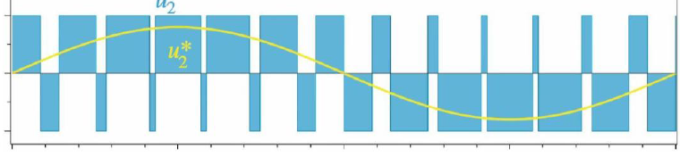

CLO 2 - 12 marks
Question 7 [2 points]: Explain how solar radiation changes with time in a specific location.
Solar radiation at a location varies with time of day (low in morning/evening, peak at noon when the Sun is highest) and with season (higher in summer, lower in winter due to Sun’s path and tilt of Earth).
Question 8 [1 point]: Explain how solar radiation changes with latitude at a specific time.
At a fixed time, solar radiation is higher near the equator and decreases toward the poles because the Sun’s rays strike at a lower angle. For a specific latitude and time, radiation also changes between the northern and southern hemisphere.
Question 9 [1 point]: What is the optimum angle for solar panels at the following coordinates (33.8727° S, 151.2057° E).
The optimum tilt angle ≈ latitude, so about 34° facing north (since it is in the Southern Hemisphere).
Question 10 [4 points]: A house in Karachi requires 20 kWh/day of electricity. You are tasked with sizing a PV array to meet this demand. Find the minimum number of panels needed to meet this requirement.
Peak Sun Hours (PSH): 5.5 h/day, PV module rated power: 400 Wp (at STC: 25°C, 1000 W/m²), Module efficiency at STC: 18%, Temperature coefficient of efficiency: –0.45%/°C, Average cell operating temperature: 45 °C, System performance ratio (wiring, inverter, dust losses, etc.): 0.75
$$Temperature loss= -0.45 \%×{20}^{∘}C=-9\% \\ P_{eff}​=400 W×\left(1-0.09\right)=400×0.91=364 W \\ P_{use​}=364 W×0.75=273 W$$
$$E_{panel}​=P_{use}​×PSH=273 W×5.5 h=1501.5 Wh=\frac{1.5015 kWh}{day}.$$
$$N=\frac{20 kWh}{1.5015 kWh}​≈13.32⇒ 14 panels (must be integer).$$
Question 11 [4 point]: On 25th September (non-leap year), at 15:00 local time (PKT, UTC+5), calculate the solar altitude angle and the solar azimuth angle for Karachi, Pakistan.
Use these values in your solution:
- Latitude: ϕ = 24.86∘N, Longitude = 67.01° E
- Standard meridian for PKT: Lst=75° E
- Day number: n=268 (25 Sept, non-leap year)
- Solar declination: δ=−1.66°
- Solar time: ST=15.688 hours (≈ 15:41)
$$H=15\left(15.688-12\right)=15×3.688={55.320}^{∘}$$
$$sin\left(α\right)​=\sin\left(ϕ\right)\sin\left(δ\right)+cos\left(ϕ\right)cos\left(δ\right)\cos\left(H\right) \\ α= {30.26}^{∘}$$
$$cos⁡(γ)=[sin⁡(δ)cos⁡(ϕ)-cos⁡(δ)sin⁡(ϕ)cos⁡(H)]/\cos{α }$$
$$γ≈{107.89}^{∘}$$
$$Quadrant correction : 252.107$$

